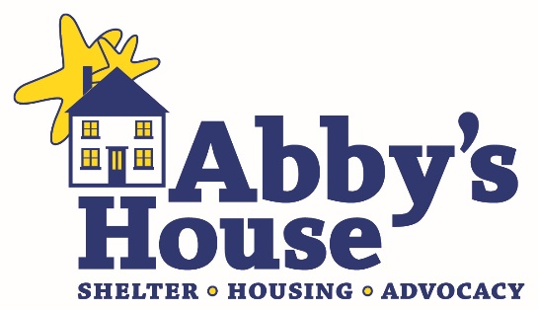

Abby’s House 14th Annual Hybrid 5K Run/Walk
Presented by TJX
October 7 – 14, 2023

Important Links:
Abby’s House Event Page: abbyshouse.org/event/14th-annual-abbys-house-hybrid-5k-run-walk/
Event details, links for registration and online auction, corporate and individual fundraising options, information on how you are supporting women and children at Abby’s House
Racewire Registration: abbyshouse.racewire.com
Individual and Team registration, including Race Fees, Deadlines, Bib Pick-Up, Awards, & more. Set a goal and fundraise to support the mission of Abby’s House.
Online Auction: www.32auctions.com/abbyshouse5k2023
Featuring items from local businesses, auction opens at 9 a.m. on 10/7 and closes at 8 p.m. on 10/14!
Abby’s House Social Media Accounts
Follow and Share! Find us on Facebook, Twitter, Instagram @abbyshouse1976

Mission: The mission of Abby’s House is to provide shelter and affordable housing, as well as advocacy and support services, to homeless, battered, and low-income women, with or without children.

Spread the word about the event and mission of Abby’s House to encourage giving to your personal fundraiser! Here’s how:

Tell your story – Why You Support and Participate in the Abby’s House 5K
Your words make an impact on family and friends, so share why you choose to support Abby’s House! Don't hesitate to pull at their heartstrings; people are more likely to give/get involved if there's an emotional connection.

Social Media Posts
Share our posts and add your own words of support! Or, create your own posts about supporting the 14th Annual Hybrid 5K Run/Walk! Don’t forget to tag @abbyshouse1976 in your social posts and use hashtags #AbbysHouse5K #FiveToHelpHerThrive.

If you don’t have social media, please email us at events@abbyshouse.org and share why you’re participating in the race, why you support Abby’s House, and any photos you may have from previous races. We’ll then share them with our community to help inspire others to join in the fun!

Send Emails
Share the 14th Annual Hybrid 5K Run/Walk emails to your own personal email list! You can email events@abbyshouse.org to request being added to this year’s 5K email list. (Or to sign up for all Abby’s House emails, visit abbyshouse.org and scroll to bottom of page to sign up!)

How often should I communicate with my network?
There are four top times you should communicate with your network during this campaign!
1. Now – Oct 1st – Register, build your team, share ways your friends and family can support the race, bid on online auction items, make a donation, and help spread the word through social media and email
2. Oct 1st – 14th – Reminders to your networks and team members, and follow-up through social media and emails
3. Oct 14th – 15th - Final push for donations to reach the goal and asking for last minute participants to join in the in-person race on Saturday, October 15th
4. Oct 17th – Final Numbers Are Coming Out, Share a thank you with your networks!

During the final push phase of the campaign, increasing your frequency to a few social posts a day has proven to be highly effective, so go for it!

How You Can Create a Personal Fundraiser
Create your own fundraising page on Racewire, share why you support Abby’s House, set a fundraising goal of $250, $500, $1,500 or $5,000+, and encourage your family and friends to join you! To set up your fundraising page, click here. If your friends/family prefer to send in a check:

Payable to: Abby’s House
(Memo: 5K)
ATTN: Accounting
52 High Street
Worcester, MA 01609

Or, they can give online at abbyshouse.org/event/14th-annual-abbys-house-hybrid-5k-run-walk/

Some Social Posts To Share!

- I'm participating in this year’s Abby’s House 5K because no one should ever have to face homelessness. @abbyshouse1976 has set a goal to raise $70,000 to support their Shelter, Housing, and Advocacy programs for homeless, battered, and low-income women, with or without children. This year’s race has both virtual and in-person opportunities, allowing you to participate in whatever way feels best for you! Register and join my team [insert team name here] by visiting abbyshouse.racewire.com. Together, we can help end homelessness! #AbbysHouse5K #FiveToHelpHerThrive

- In 2022, 90 women and 12 children resided in @abbyshouse1976 supportive, affordable housing. Our shelter hosted 20 total households; including 16 single women, and 4 families w/ children. This is in addition to the over 500 individuals who accessed their advocacy services each year! Join me in walking or running #FiveToHelpHerThrive so that more women and children have the chance to move out of homelessness and rebuild their lives.

- We did it! Thank you all those who joined me in completing #FiveToHelpHerThrive for @abbyshouse1976! Our support and participation helped countless women and children at risk of homelessness have access to safe shelter, affordable, supportive housing, and advocacy services that will help them thrive! #AbbysHouse5K
Any questions, please contact Kelly Whalen, Director of Development at 508-756-5486 or kelly@abbyshouse.org.

